A. Configuring changes to an existing form in the portal 2
1. Making a section or item active or inactive 5
2. Updating a section header 6
3. Updating help text 7
4. Individual Form profiles 10
5. Standard Additional Questions section 11
6. Making changes in the CoreHR Back Office 11
7. Making changes to the portal settings 12
8. Non-standard additional questions section 13
9. Testing Changes 16
B. Related Documents 18

Knowledge Article: Online Recruitment Application Forms

Configuring changes to an existing form in the portal
Changes can be made at two levels in the portal. Changes can be made to the Form Type which will apply to all application form profiles and/or changes can be made to an individual form profile.

 | NB: Changes must be made to all forms with the same profile. Refer to the knowledge article for further details.

Navigate to: Core Portal > Recruitment Dashboard > Recruitment

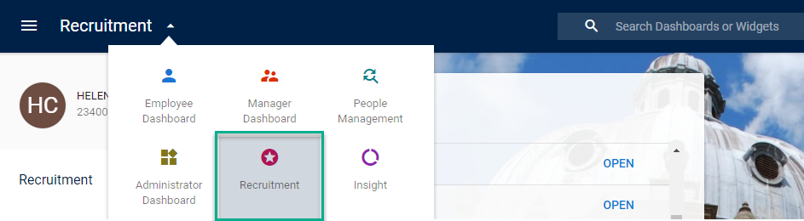

  - From the dashboard, Toolbox > Recruitment Admin

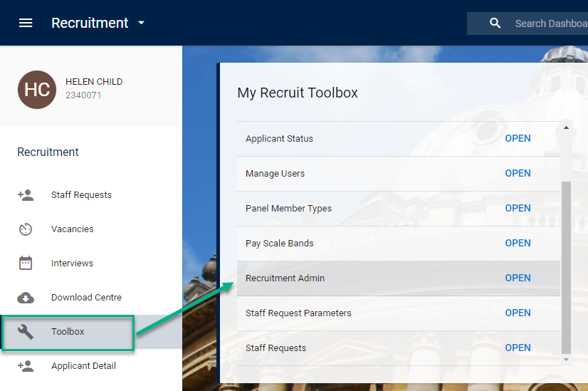

  - Select Company UNIVERSITY OF OXFORD and Form Type E-Recruitment Form.

The E-Form maintenance screen will expand to show the individual sections.

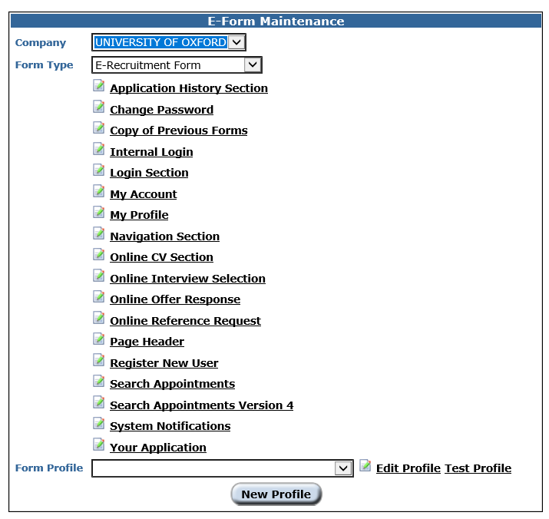

 | NB: Any changes you make here will apply to all application forms.

  - Click on the relevant section heading to access the detail e.g. Login section.
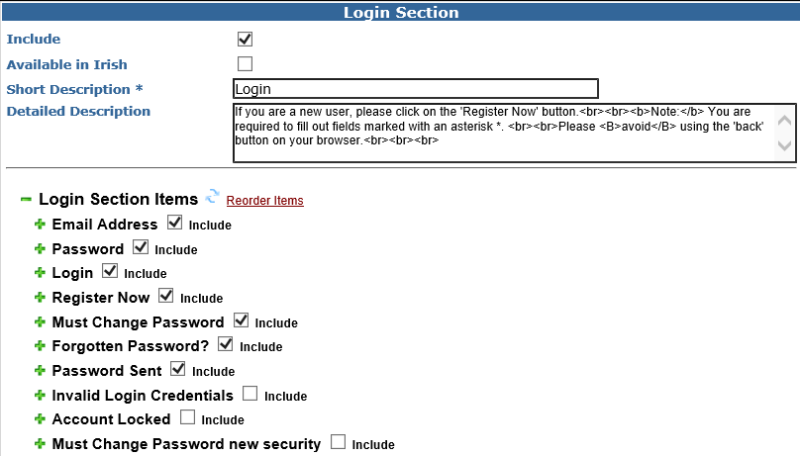

Making a section or item active or inactive

  - To make a section active or inactive tick or untick the 'Include' box.

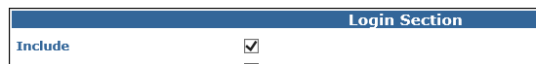
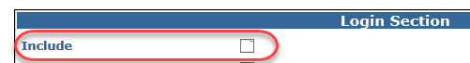

  - To change a header name edit the text in the 'Short Description'.

BEFORE
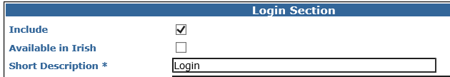
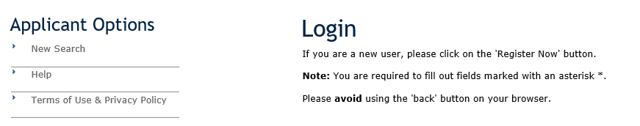

AFTER
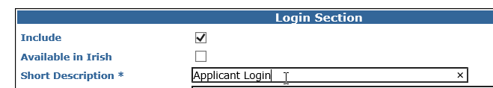
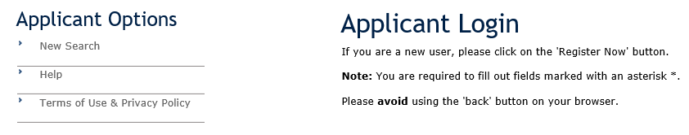

  - SAVE the changes and check that it is displayed as expected in the online Applicant portal.

Updating a section header

  - To change the explanatory text edit the text in the 'Detailed Description' box.

 | NB: This text is often updated temporarily to add details about forthcoming downtimes for maintenance. Any new text should be added above the standard text. For sample text refer to the Knowledge Article

    - Current text:
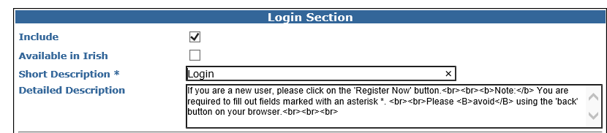

    - Viewed in the applicant portal:
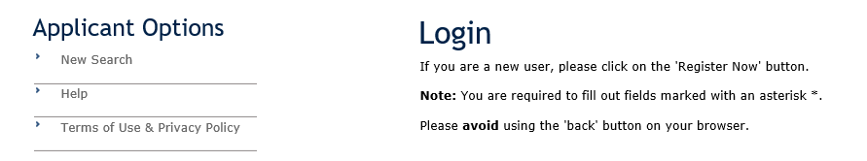

    - New text added as shown:
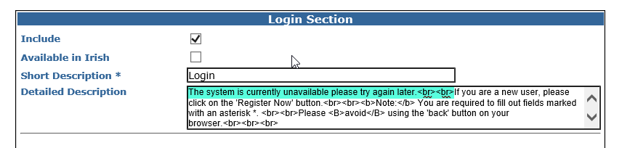

  - SAVE the changes and check that it is displayed as expected in the online Applicant portal.

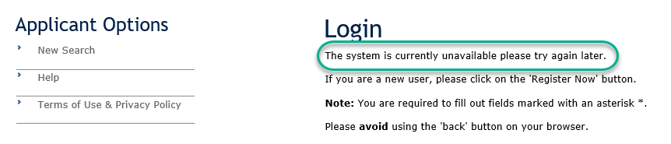

Updating help text
Additional information that can be supplied in a pop up box which is revealed when is selected by the applicant and configured within each individual section.

There are two forms of help text – Short Hint and Help Text. These can be held within the E-Form Maintenance screen or the individual Application Form Profiles.

Short hint configuration- If used, will show alongside or under the field label and is visible to the applicant. Care should be taken that it does not overlap with any of the other text.

Configuration | Appearance
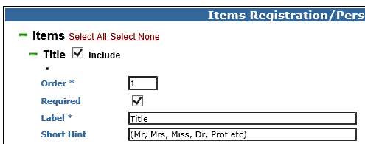 | 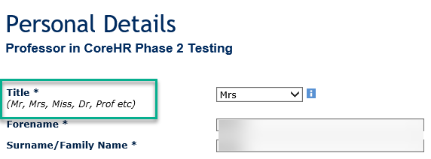

Help Text configuration

Configuration
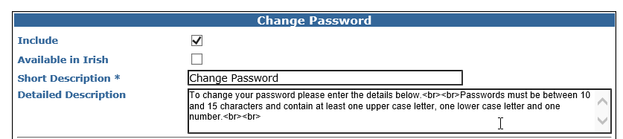

Appearance
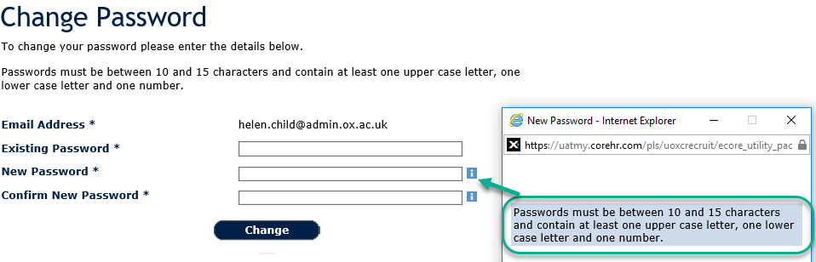

 | NB: Not every field has help text included and it can sometimes be tricky to find the correct item. You may need to open a few sections before you locate the text.

- To configure help text click on the section header e.g. Change Password | 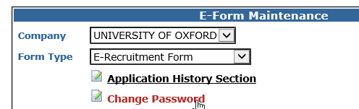

The Change Password section will open: | 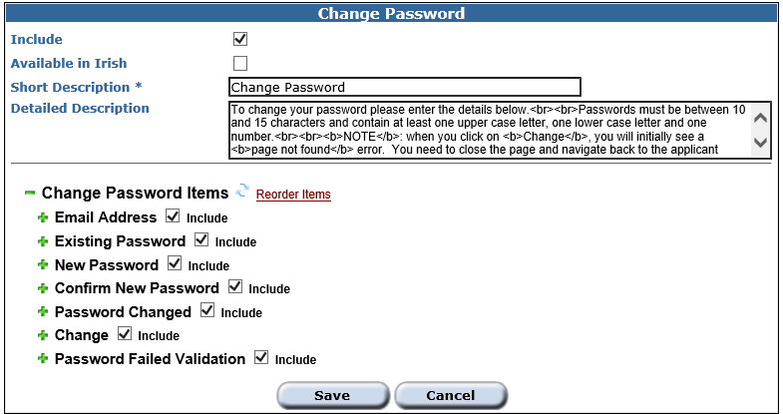

- Find the item to be updated and click on the to expand. |  | 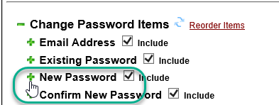
The section will open to display the current configuration | 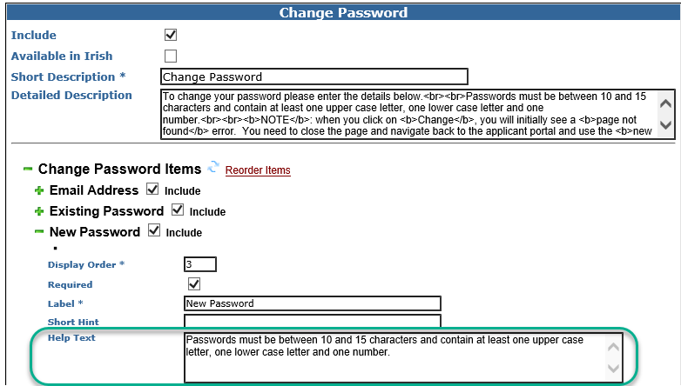

  - Update the help text as required and SAVE.

Individual Form profiles

All current application forms consist of a single Page with multiple active Sections.

  - Select the relevant Application Form in the E-Form Maintenance window.

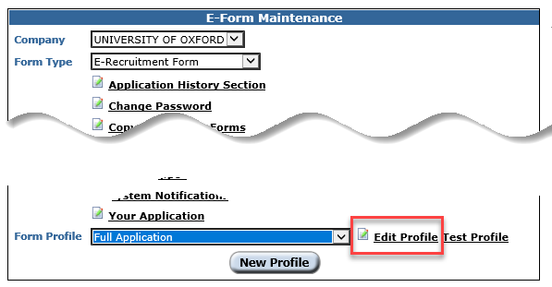

  - Click on ‘Edit Profile’ to access the profile specific sections.

Standard Additional Questions section

The current questions and change history can be found in the Questionnaire Setup document under P:\PROJECTS\HRIS Programme\12. Support\Reference Data\Application Form Profile Maintenance\Application Form Profile - Questionnaire Section.

Making changes in the CoreHR Back Office

Personnel > Recruitment > Recruitment Reference > Question Category

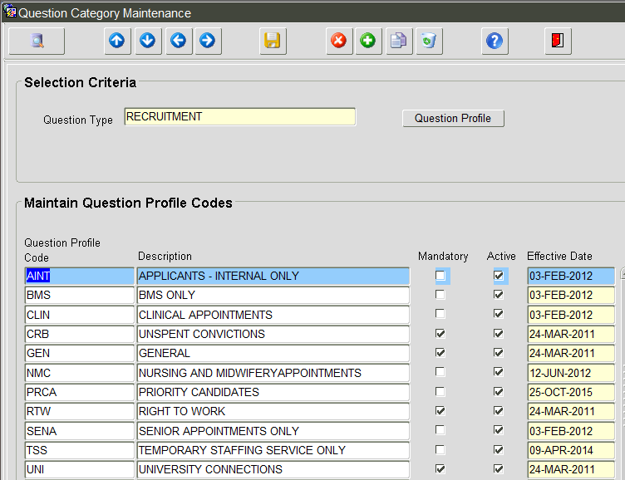

  - Click on the relevant question profile to highlight it and then click on ‘Question Profile’.

  - Update the as required e.g. deletions, additions, amendments to questions asked etc.

Making changes to the portal settings
The portal settings for the Additional Questions section are made at application form level and can be adjusted for each profile if desired. The settings for this area are recorded in the CDD for E-Recruitment Form spreadsheet alongside the other portal configuration settings in the ‘Template Detail’ spreadsheet tab.

Having selected a particular Application Template e.g. Full Application as below, select Edit for the Questionnaire Section.

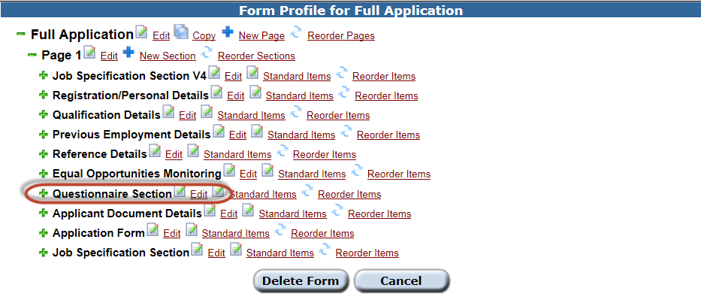

It is unlikely that the settings for this area on the staff portal side will change. They are currently as follows:

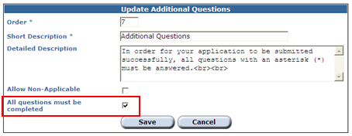

 | NB: the tick option for the ‘All questions must be completed’ item in the form above does not function in the way that this wording suggests. Whether or not a question is mandatory is entirely determined by the settings for that question in the CoreHR Back Office.

The actual meaning of the above is: this section is mandatory and must be completed. I.e. applicants will not be able to submit an application without accessing this section and completing it as per the requirements specified for the individual questions within it (i.e. any that are mandatory will need to be completed and any that are optional can be left blank).

Non-standard additional questions section

  - Firstly you need to create a new UDF following the steps in HOW TO - Create and Edit UDFs in the Portal v1.0.docx, noting the differences below:

- User Defined Type = E-Recruitment

- In advanced settings select UDF Type = 'Employees' and 'E-Recruitment'

Testing Changes
If you have made a change it's best to test it straight away.

  - Attach the relevant application form to an active vacancy, open the vacancy in Public Portal and click on ‘Apply Now’.

Related Documents

Documentation can be found under:

P:\PROJECTS\HRIS Programme\12. Support\Reference Data\Application Form Profile Maintenance

- Application Form Design Document (CDD)

- Questionnaire set up

